PET SCHEDULER AND SOCIAL CARE APP
A Project Report
Submitted in Partial fulfilment of the
Requirements for the award of the Degree of

BACHELOR OF SCIENCE (INFORMATION TECHNOLOGY)
By

Ansari Zoya Banu Sajid Akhtar
Seat Number: 3008498

Under the esteemed guidance of
Prof. Ms. Hina Mahmood
ASSISTANT PROFESSOR



DEPARTMENT OF INFORMATION TECHNOLOGY
RIZVI COLLEGE OF ARTS, SCIENCE AND COMMERCE
(Affiliated to University of Mumbai)
MUMBAI-400050 MAHARASHTRA
2025-2026

PROFORMA FOR THE APPROVAL PROJECT PROPOSAL
PRN No.:2023016400020701 Roll no: 13
1. Name of the Student: - Ansari Zoya Banu Sajid Akhtar
2. Title of the Project: - Pet Scheduler and Social Care App
3. Name of the Guide: - Prof. Ms. Hina Mahmood
4. Teaching experience of the Guide: - 14 Years
5. Is this your first submission?

Yes No

Signature of the Student Signature of the Guide
Date: ………………… Date: …………………….

Signature of the Coordinator
Date: ………………
RIZVI COLLEGE OF ARTS, SCIENCE AND COMMERCE
(Affiliated to University of Mumbai)
MUMBAI-MAHARASHTRA-400050

DEPARTMENT OF INFORMATION TECHNOLOGY

CERTIFICATE

This is to certify that the project entitled, "Pet Scheduler and Social Care App ", is Bonafide work of “Ansari Zoya Banu Sajid Akhtar” bearing Seat No: 3008498 submitted in partial fulfilment of the requirements for the award of degree of BACHELOR OF SCIENCE in INFORMATION TECHNOLOGY from University of Mumbai.

Project Guide Coordinator

External Examiner

Date: __________ College seal

ABSTRACT

The Pet Scheduler and Social Care App is a smart and user-friendly platform developed to help pet owners manage their pets’ daily needs in an organized and efficient manner. In today’s fast-moving lifestyle, many pet owners face difficulties in keeping track of pet health records, vaccination schedules, appointments, food purchases, and social engagement. Traditional methods such as manual notes, reminders, and separate applications often create confusion and inefficiency.
To overcome these problems, this project proposes an all-in-one mobile application that combines pet care management, social networking, appointment scheduling, vaccination tracking, gallery management, location-based services, shopping, and secure chat features into a single platform. The application enables users to register and log in securely, create pet profiles, schedule appointments, maintain vaccination history, upload pet photos, and connect with other pet lovers through posts, likes, comments, and follow features.
In addition, the system provides nearby clinic and pet store discovery, pet-friendly location search, and online product purchase with secure payment integration. It also supports one-to-one private messaging between users. By integrating all these modules, the application offers convenience, efficiency, and better pet care planning.
The project aims to provide a scalable and secure digital ecosystem for pet owners while reducing manual effort and improving access to essential pet services. This application can be highly useful for individual pet owners, veterinary support systems, pet communities, and future smart pet-care platforms.

ACKNOWLEDGEMENT

I would like to express my sincere gratitude to my project guide, Prof. Ms. Hina Mahmood, for his guidance and support in completing this project on time. His timely advice and constant encouragement were invaluable to me. I would like to thank our principal Dr. S. Arunachalam who has always been the source of inspiration. We are also thankful to Mr. Sameer Shaikh, our coordinator for all the help he has rendered to ensure the successful completion of the project. We are also thankful for and fortunate enough to get constant encouragement, support, and guidance from the teachers of information Technology who helped us in successfully completing my project work. The department of Information Technology & Computer Science has provided me the access of resources and facilities, that I needed to complete my project.

DECLARATION

I hereby declare that the project entitled, " Pet Scheduler and Social Care App ", carried out at Rizvi College, Mumbai, is my original work and has not been submitted to any other university or institution for the award of any degree or diploma. To the best of my knowledge, no one other than myself has contributed to this project in a way that would require acknowledgment as co-author. This project has been completed in partial fulfillment of the requirements for the award of the degree of Bachelor of Science (Information Technology) and is submitted as part of the final semester project curriculum.

Ansari Zoya Banu Sajid Akhtar

TABLE OF CONTENT
CHAPTER 1. INTRODUCTION 01
1.1 Background 01
1.2 Problem Statement 01
1.3 Scope of Project 02
1.4 Objectives 04
1.5 Organization of Report 05

CHAPTER 2. SURVEY OF TECHNOLOGIES 07
2.1 Mobile Application Development 07
2.2 Frontend Technologies 07
2.3 Backend Technologies 09
2.4 Database Technologies 10
2.5 Authentication and Security 11
2.6 Payment Integration 13
2.7 Location and Mapping Services 14

CHAPTER 3. REQUIREMENT ANALYSIS 16
3.1 Existing System 16
3.2 Proposed System 17
3.3 Functional Requirements 19
3.3.1 User Management 20
3.3.2 Pet Profile Management 21
3.3.3 Appointment and Reminder System 21
3.3.4 Vaccination Management 22
3.3.5 Media Management 22
3.3.6 Social Interaction Model 22
3.3.7 Chat System 23
3.3.8 Location-Based Services 23
3.3.9 E-commerce Module 23
3.3.10 Notification System 24
3.4 Non-Functional Requirements 24
3.4.1 Security 24
3.4.2 Performance 25
3.4.3 Scalability 25
3.4.4 Reliability 25
3.4.5 Usability 25
3.4.6 Maintainability 26
3.4.7 Availability 26
3.5 Hardware and Software Requirements 26
3.5.1 Software Requirements 26
3.5.2 Hardware Requirements 27

CHAPTER 4. SYSTEM DESIGN 28
4.1 System Architecture 28
4.1.1 Components of the Architecture 28
4.1.2 Architecture Flow 30
4.2 Modules of the System 31
4.2.1 Authentication Module 32
4.2.2 Dashboard & Navigation 32
4.2.3 Pet Profile Management 32
4.2.4 Appointment Scheduler 33
4.2.5 Vaccination Tracker 33
4.2.6 Photo Gallery 34
4.2.7 Pet Social Network 34
4.2.8 Encrypted Chat 34
4.2.9 Nearby Clinics & Reviews 35
4.2.10 Pet Food & Toy Store 35
4.2.11 Payment Integration 35
4.2.12 Pet-Friendly Locations 36
4.3 Use Case Description 36
4.4 Data Design 37
4.5 User Interface Design 39
4.6 Testing Strategy 40
4.6.1 Unit Testing 40
4.6.2 Integration Testing 40
4.6.3 API Testing 40
4.6.4 UI Testing 40
4.6.5 Performance Testing 40
4.6.6 Security Testing 41

CHAPTER 5. IMPLEMENTATION AND TESTING 42
5.1 Implementation Approach 42
5.2 Module Implementation 44
5.2.1 Authentication Module 44
5.2.2 Pet Management Module 44
5.2.3 Appointment Module 45
5.2.4 Vaccination Module 46
5.2.5 Gallery Module 46
5.2.6 Social Module 47
5.2.7 Chat Module 47
5.2.8 Location Module 48
5.2.9 Shopping Module 48
5.2.10 Payment Module 49
5.3 API Integration 50
5.4 Testing Methods 52
5.4.1 Unit Testing 52
5.4.2 Integration Testing 52
5.4.3 System Testing 52
5.4.4 Beta Testing 52
5.4.5 Performance Testing 53
5.4.6 Security Testing 53

CHAPTER 6. RESULTS AND DISCUSSION 54
6.1 System Output 54
6.1.1 User Registration and Login 54
6.1.2 Pet Profile Management 54
6.1.3 Appointment Scheduling 55
6.1.4 Vaccination Tracking 55
6.1.5 Gallery Management 56
6.1.6 Social Interaction 56
6.1.7 Chat System 56
6.1.8 Location-Based Services 57
6.1.9 Shopping Module 57
6.1.10 Payment System 57
6.1.11 Overall System Performance 58
6.2 Advantages of the System 58
6.3 Limitations 59
6.4 Discussion 60

CHAPTER 7. CONCLUSION AND FUTURE SCOPE 62
7.1 Conclusion 62
7.2 Future Scope 63
7.2.1 Online Veterinary Appointment Booking 63
7.2.2 AI-Based Health Recommendations 64
7.2.3 Smart Reminders with Notifications 64
7.2.4 Multi-User Family Access 64
7.2.5 Pet Adoption and Rescue Section 65
7.2.6 Video Calling with Veterinarians 65
7.2.7 Live Order Tracking 65
7.2.8 Advanced Chat Encryption 66
7.2.9 Web Version of the Platform 66
7.2.10 Wearable Pet Device Integration 66

LIST OF FIGURES
Fig 1.1 Pet Care App Framework 03
Fig 2.1 Secure Authentication 12
Fig 2.2 Pet Care App Technology Stack 14
Fig 3.1 Requirement Flow 18
Fig 3.2 Use Cases of Pet Care App 20
Fig 4.1 System Architecture Diagram Flow 28
Fig 4.2 DFD Level: Pet Care System 31
Fig 4.3 Entities and Relationships 37
Fig 5.1 Software Implementation Cycle 42
Fig 5.2 API Flow Cycle 51

CHAPTER 1. INTRODUCTION
1.1 Background
Pets are considered an important part of many families and are often treated as companions or family members. They require regular care, including proper nutrition, medical attention, grooming, vaccination, and emotional bonding. Managing all these responsibilities can be challenging, especially for pet owners who have busy schedules or multiple pets.
In many cases, pet-related information such as health records, vaccination dates, appointment details, and feeding schedules are maintained manually using notebooks, calendars, or scattered across different mobile applications. This unorganized approach often leads to confusion, missed reminders, and difficulty in accessing important information when needed.
With the advancement of technology, mobile applications have become an essential part of daily life. They offer convenience, accessibility, and real-time management of various tasks. A dedicated pet care mobile application can significantly improve the way pet owners manage their responsibilities by providing a centralized platform.
Such an application can help users store pet records, set reminders for appointments and vaccinations, upload and manage pet photos, discover nearby clinics and services, purchase pet products, and interact with other pet owners. By integrating all these functionalities into a single platform, the proposed system aims to simplify pet care management and enhance the overall experience of pet ownership.

1.2 Problem Statement
Pet owners often face several challenges while managing their pets due to the lack of a unified system. These problems affect both the efficiency of pet care and the convenience of the users.
• Difficulty in maintaining pet health records and profiles:
Pet details such as age, breed, medical history, and allergies are often stored manually or across different platforms, making it difficult to access and update information easily.
• Missed appointment and vaccination dates:
Without proper reminders, pet owners may forget important appointments or vaccination schedules, which can negatively impact the pet’s health.
• Lack of a centralized platform for pet-related activities:
Users have to rely on multiple applications for different tasks such as reminders, shopping, social interaction, and location search, which is time-consuming and inefficient.
• Difficulty in finding nearby clinics, stores, and pet-friendly locations:
Pet owners often struggle to locate reliable veterinary clinics, pet stores, parks, and restaurants that allow pets.
• Inconvenient shopping process for pet products:
Buying pet food, toys, and accessories requires switching between different e-commerce platforms, which may not be specifically tailored for pet needs.
• Limited communication between pet owners in one dedicated space:
There is no dedicated social platform where pet owners can interact, share experiences, and learn from each other.
• Lack of secure private chat and social engagement focused on pets:
Existing platforms do not provide secure and pet-focused communication systems, limiting meaningful interaction among users.

1.3 Scope of Project
The scope of this project is to design and develop a comprehensive mobile application that provides a centralized and user-friendly platform for managing all pet-related activities.
The application includes the following functionalities:
• User registration and login:
Allows users to create accounts and securely log in to access personalized features.
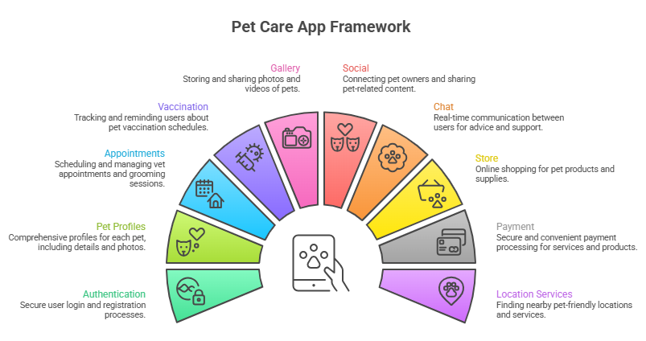
Fig 1.1 Pet Care App Framework

• Pet profile management:
Enables users to add, edit, and manage detailed profiles of their pets, including basic and medical information.
• Appointment scheduler:
Helps users schedule, update, and manage appointments such as vet visits and grooming sessions.
• Vaccination tracking:
Allows users to record vaccination details, track due dates, and receive reminders.
• Photo gallery:
Provides a space for users to upload, store, and organize pet images.
• Social media features for pets:
Enables users to share posts, images, and videos of their pets, and interact with other users through likes and comments.
• Secure direct messaging:
Supports private communication between users for better interaction and networking.
• Nearby clinics and store search:
Uses location-based services to help users find nearby veterinary clinics and pet stores.
• Pet product shopping and payment integration:
Allows users to browse products, add items to cart, and make secure online payments.
• Pet-friendly restaurant and park discovery:
Helps users locate places where pets are allowed and provides user reviews and ratings.
The system is primarily designed for pet owners but can be expanded in the future to include veterinary professionals, pet shelters, trainers, and product vendors.

1.4 Objectives
The main objectives of the project are to develop a system that simplifies pet care and enhances user experience through efficient digital solutions.
- To provide a secure and easy-to-use platform for pet owners:
The application aims to ensure user data security while maintaining a simple and user-friendly interface.
- To maintain complete pet information in one place:
All pet-related data such as profiles, medical records, and history will be stored in a centralized system.
- To help users schedule and manage appointments effectively:
The system will allow users to create, update, and track appointments with reminder functionality.
- To keep track of vaccination records and reminders:
Users can record vaccination details and receive alerts for upcoming doses.
- To allow users to upload and organize pet photos:
The gallery feature will help users store and categorize images of their pets.
- To create a social network where pet owners can share posts, photos, and videos:
The platform will encourage community engagement and sharing among pet lovers.
- To enable private and secure user-to-user chat:
The application will provide a messaging system for direct communication between users.
- To help users locate nearby clinics, stores, and pet-friendly places:
Location-based services will assist users in finding essential pet services easily.
- To provide e-commerce functionality for pet products:
Users can browse, select, and purchase pet products within the application.
- To support safe digital payments and order tracking:
The system will ensure secure transactions and provide order details and tracking features.

1.5 Organization of Report
This project report is structured into seven chapters, each focusing on a specific aspect of the system development process.
• Chapter 1: Introduction
Provides an overview of the project, including background, problem statement, scope, and objectives.
• Chapter 2: Survey of Technologies
Describes the technologies used for developing the application, including frontend, backend, database, and supporting tools.
• Chapter 3: Requirement Analysis
Explains the existing system, proposed system, functional and non-functional requirements, and feasibility study.
• Chapter 4: System Design
Covers system architecture, module design, data flow, and user interface design.
• Chapter 5: Implementation and Testing
Describes the development process, tools used, API integration, and testing methods.
• Chapter 6: Results and Discussion
Presents the output of the system, advantages, and limitations.
• Chapter 7: Conclusion and Future Scope
Summarizes the project and discusses possible future enhancements.

CHAPTER 2. SURVEY OF TECHNOLOGIES
2.1 Mobile Application Development
Mobile application development plays a crucial role in modern digital systems, especially in domains where users require constant access to services. In the case of a pet care management system, a mobile application provides a convenient and efficient way for users to manage all pet-related activities anytime and anywhere.
With the rapid increase in smartphone usage, mobile applications have become the most preferred platform for accessing services. A dedicated mobile application allows pet owners to perform multiple tasks such as maintaining pet profiles, tracking vaccination schedules, booking appointments, uploading images, communicating with other users, and locating nearby pet services.
Unlike traditional web applications, mobile applications offer several advantages such as better performance, faster loading speed, offline support, and enhanced user experience. One of the most important features is push notifications, which help in sending real-time alerts such as vaccination reminders, appointment notifications, and order updates.
Mobile applications also provide seamless integration with device features such as:
- GPS for location tracking
- Camera for capturing and uploading pet images
- Storage for saving media files
- Notifications for real-time updates
These integrations enhance the functionality and usability of the application.
Additionally, the use of cross-platform development frameworks allows developers to create applications that run on both Android and iOS using a single codebase. This reduces development time, cost, and effort while ensuring consistency across platforms.

2.2 Frontend Technologies
The frontend of the application is developed using React Native with Expo, which is a powerful and widely used framework for building cross-platform mobile applications.
React Native allows developers to use JavaScript and React concepts to build mobile interfaces. It follows a component-based architecture, where the UI is divided into reusable components. This makes the application more organized, scalable, and easy to maintain.
Expo enhances the development process by providing pre-configured tools and libraries, eliminating the need for complex setup. It also allows developers to test applications instantly on real devices using the Expo Go app, which speeds up the development and debugging process.
Advantages of React Native with Expo
- Cross-platform compatibility (Android and iOS)
- Faster development using reusable components
- Live reloading for instant updates
- Easy integration with APIs and backend services
- Access to device features like camera, GPS, and storage
The frontend is responsible for:
- Handling user interactions (clicks, inputs, gestures)
- Displaying data received from the backend
- Managing application states
- Providing smooth navigation between screens
Screens such as login, dashboard, pet profiles, appointments, gallery, chat, and store are designed using modern UI/UX principles.
Navigation is handled using libraries such as React Navigation, which ensures smooth transitions between screens and improves user experience.

2.3 Backend Technologies
The backend of the application is developed using Node.js and Express.js, which are widely used for building scalable and efficient server-side applications.
Node.js is a runtime environment that allows JavaScript to run on the server. It uses a non-blocking, event-driven architecture, which makes it highly efficient in handling multiple user requests simultaneously. This is particularly useful for applications with real-time features such as chat and notifications.
Express.js is a lightweight web framework built on top of Node.js. It simplifies backend development by providing features such as routing, middleware, and request handling.
Responsibilities of Backend
- Handling user authentication and authorization
- Processing API requests from frontend
- Managing pet data and user profiles
- Handling appointment and vaccination data
- Supporting chat functionality
- Managing product listings, orders, and payments
RESTful APIs
The backend exposes RESTful APIs, which act as a communication bridge between frontend and backend.
These APIs allow operations such as:
- Create (POST)
- Read (GET)
- Update (PUT)
- Delete (DELETE)
Middleware
Middleware functions are used to:
- Authenticate users
- Validate requests
- Handle errors
- Log system activities
This ensures that the system remains secure and efficient.

2.4 Database Technologies
The system uses MongoDB, which is a NoSQL, document-oriented database.
Unlike traditional relational databases, MongoDB stores data in JSON-like documents, making it flexible and easy to work with. This is especially useful for applications where data structures can change over time.
Advantages of MongoDB
- Flexible schema design
- High scalability
- Fast data retrieval
- Easy integration with Node.js
Data Stored in Database
- User details (name, email, phone)
- Pet profiles (name, breed, age, health records)
- Appointment details
- Vaccination records
- Chat messages
- Social posts and comments
- Product and order information
MongoDB organizes data into collections, where each collection contains multiple documents.
Example collections:
- Users
- Pets
- Appointments
- Vaccinations
- Products
- Orders
MongoDB Atlas
MongoDB Atlas (cloud version) can be used for hosting the database. It provides:
- Automatic backups
- Data security
- Scalability
- Remote access

2.5 Authentication and Security
Security is one of the most important aspects of the system, as it handles sensitive user data.
The application uses secure authentication mechanisms to ensure that only authorized users can access the system.
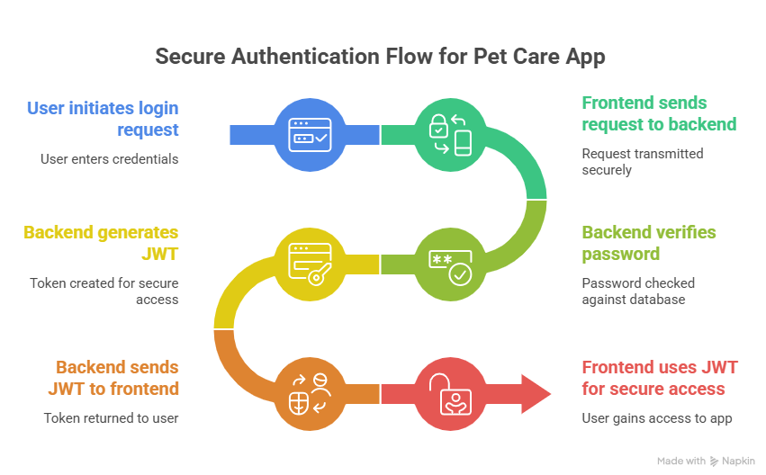
Fig 2.1 Secure Authentication Flow

Authentication Process
- User logs in with email and password
- Backend verifies credentials
- A JWT (JSON Web Token) is generated
- Token is used for future authentication
Security Measures
- Password encryption using bcrypt
- Secure API endpoints
- Token-based authentication
- Input validation and sanitization
- Protection against common attacks such as:
  - SQL Injection
  - Cross-Site Scripting (XSS)
Additional Security Features
- Role-based access control (optional)
- HTTPS protocol for secure communication
- Session management
These measures ensure data privacy and system security.

2.6 Payment Integration
The application includes a payment system to support online purchases of pet-related products.
Supported Payment Methods
- UPI (Unified Payments Interface)
- Credit/Debit Cards
- Digital Wallets
Payment gateways such as Razorpay or Stripe are integrated into the system using APIs.
Features of Payment System
- Secure transaction processing
- Order confirmation
- Payment history tracking
- Receipt generation
- Refund handling (if required)
Security in Payments
- Encryption of transaction data
- Compliance with payment standards
- No storage of sensitive card details
This ensures safe and reliable transactions for users.

2.7 Location and Mapping Services
Location-based services are essential for helping users find nearby pet-related facilities.
Technologies Used
- GPS (Global Positioning System)
- Google Maps API (or similar mapping services)
Features
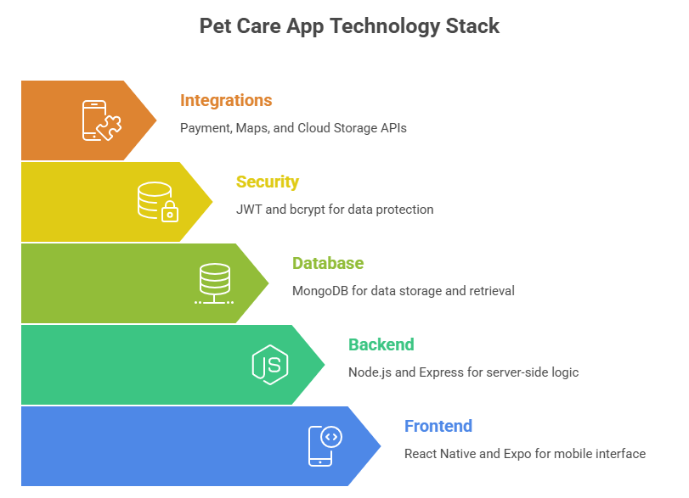
Fig 2.2 Pet Care App Technology Stack

- Real-time location tracking
- Searching nearby clinics, stores, parks
- Distance calculation
- Route and navigation guidance
- Displaying map-based interfaces
Users can easily find nearby services and navigate to them, improving accessibility and convenience.
Location data can also be used to provide personalized recommendations based on the user’s area.

CHAPTER 3. REQUIREMENT ANALYSIS
3.1 Existing System
In the current scenario, pet owners rely on multiple independent applications and manual methods to manage different aspects of pet care. This fragmented approach creates inefficiency, confusion, and lack of coordination between tasks.
Most pet owners use simple tools such as notebooks, diaries, or note-taking applications to store pet-related information like vaccination history, feeding schedules, and medical conditions. Although this method is easy to use, it lacks automation, structured storage, reminders, and quick accessibility, especially during emergencies.
For managing appointments such as veterinary visits, grooming sessions, or training classes, users typically depend on calendar applications. While calendars provide reminder notifications, they are not specifically designed for pet-related activities and do not include detailed information about pets, such as medical history or special care instructions.
Communication with veterinarians or other pet owners is usually done through general messaging platforms. These applications are not integrated with pet-related data, making it difficult to maintain structured conversations or quickly share pet information like health records or vaccination details.
When purchasing pet-related products such as food, toys, and accessories, users rely on separate e-commerce platforms. This process requires additional effort for searching, comparing products, and managing orders, as these platforms are not specialized for pet care and do not provide personalized recommendations.
Similarly, users depend on map-based applications to find nearby veterinary clinics, pet stores, parks, and pet-friendly restaurants. While these applications provide navigation and location services, they lack filtering options specific to pets and do not provide detailed pet-related reviews or recommendations.
Limitations of the Existing System
- Lack of integration between different services and platforms
- Time-consuming due to frequent switching between applications
- No centralized data storage for pet-related information
- Increased chances of missing important reminders and schedules
- Lack of personalized recommendations for pet care
- Limited support for pet-specific features
- No dedicated platform for pet-focused social interaction
These limitations clearly indicate the need for a centralized and integrated system that can manage all pet-related activities efficiently in one place.

3.2 Proposed System
The proposed system is a comprehensive mobile application designed to integrate all pet-related services into a single platform. It aims to eliminate the limitations of the existing system by providing a centralized, efficient, and user-friendly solution.
This application allows users to manage pet profiles, maintain health records, schedule appointments, track vaccinations, upload media, interact socially, and purchase pet-related products—all within one interface.

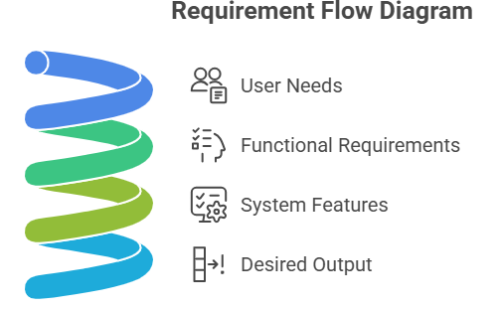
Fig 3.1 Requirement Flow

The system is developed using a user-centric design approach, focusing on simplicity, accessibility, and performance. It reduces dependency on multiple applications and improves productivity by combining all functionalities into one system.
Key Features of the Proposed System
- Centralized pet management system
- Digital storage of pet records and history
- Automated reminders for appointments and vaccinations
- Social networking features for pet owners
- Integrated e-commerce platform for pet products
- Real-time chat functionality
- Location-based services for nearby clinics, stores, and parks
Advantages of the Proposed System
- Saves time by eliminating the need to switch between multiple applications
- Improves organization of pet-related data in one place
- Enhances user experience through a unified interface
- Provides personalized and relevant services
- Increases reliability and accessibility of information
- Supports better decision-making using structured data
The proposed system provides a seamless and efficient digital experience, making pet care management easier, faster, and more effective.

3.3 Functional Requirements
Functional requirements define the specific features and operations that the system must perform. These requirements describe how the system should behave when users interact with it.
3.3.1 User Management
The system must provide secure user authentication and account management features.
Users should be able to:
- Create an account by entering personal details such as name, email, phone number, and password
- Log in using valid credentials
- Log out securely from the system
- Update profile information such as name, contact details, and preferences
- Upload and update profile images
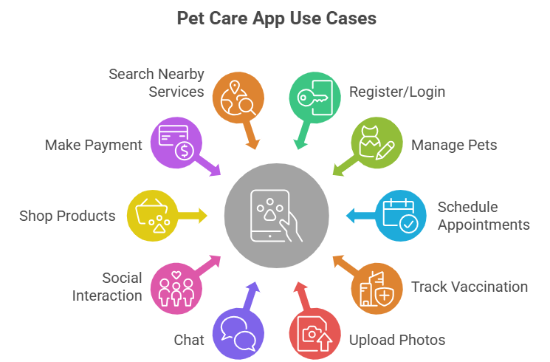
Fig 3.2 Use Cases of Pet Care App

The system must validate user input and ensure secure storage of credentials using encryption techniques.
3.3.2 Pet Profile Management
The system should allow users to manage multiple pet profiles efficiently.
Features include:
- Adding new pet profiles
- Editing existing pet details
- Deleting pet profiles
- Viewing detailed pet information
Each pet profile should store:
- Basic details (name, breed, age, gender)
- Health information (weight, medical conditions)
- Profile image
This functionality ensures proper organization and easy access to pet-related data.
3.3.3 Appointment and Reminder System
The system should provide scheduling functionality for managing appointments.
Key features:
- Scheduling new appointments
- Updating or canceling appointments
- Setting reminders for upcoming events
- Receiving notifications for scheduled appointments
- Viewing appointment history
This helps users manage time effectively and ensures timely visits to veterinarians or grooming centers.
3.3.4 Vaccination Management
The system should allow users to maintain and track vaccination records.
Features include:
- Adding vaccination details
- Updating existing records
- Setting reminders for upcoming vaccinations
- Viewing vaccination history
This ensures proper health monitoring and prevents missed vaccinations.
3.3.5 Media Management
The system should support uploading and managing media files related to pets.
Functionalities include:
- Uploading images and videos
- Organizing media files based on pets
- Viewing media gallery
- Deleting unwanted files
This feature allows users to maintain a digital collection of pet memories.
3.3.6 Social Interaction Module
The application includes a social networking module for user interaction.
Features include:
- Creating posts with text, images, or videos
- Liking and commenting on posts
- Following and unfollowing other users
- Viewing a personalized feed
This module enhances user engagement and builds a community of pet lovers.
3.3.7 Chat System
The system should include a real-time messaging feature.
Functionalities include:
- One-to-one messaging between users
- Sending text messages
- Sharing images and media
- Viewing chat history
This feature enables direct communication between users.
3.3.8 Location-Based Services
The system should provide GPS-based services to locate nearby facilities.
Features include:
- Searching nearby veterinary clinics
- Locating pet stores and parks
- Viewing directions using maps
- Accessing reviews and ratings
This helps users find relevant services quickly and efficiently.
3.3.9 E-commerce Module
The system should support online shopping for pet products.
Functionalities include:
- Browsing product listings
- Viewing product details
- Adding items to cart
- Placing orders
- Making payments
This feature simplifies the process of purchasing pet-related items.
3.3.10 Notification System
The system should provide real-time notifications to users.
Examples include:
- Appointment reminders
- Vaccination alerts
- Order status updates
- Social interaction notifications (likes, comments, messages)
Notifications ensure that users stay updated and do not miss important events.

3.4 Non-Functional Requirements
Non-functional requirements define the quality and performance characteristics of the system.
3.4.1 Security
The system must ensure strong data protection through:
- Password encryption using hashing
- Secure authentication mechanisms
- Data privacy policies
- Protection against unauthorized access
3.4.2 Performance
The application should:
- Load quickly
- Respond to user actions without delay
- Handle multiple users efficiently
- Provide smooth navigation
3.4.3 Scalability
The system should be designed to:
- Support increasing number of users
- Handle large amounts of data
- Allow addition of new features in the future
3.4.4 Reliability
The system should:
- Operate consistently without failures
- Maintain data accuracy
- Provide backup and recovery mechanisms
3.4.5 Usability
The application should be:
- Easy to understand and use
- User-friendly and intuitive
- Accessible to users with basic technical knowledge
3.4.6 Maintainability
The system should:
- Be easy to update and modify
- Support debugging and improvements
- Allow efficient maintenance
3.4.7 Availability
The system should:
- Be available to users at all times
- Minimize downtime
- Ensure continuous service

3.5 Hardware and Software Requirements
3.5.1 Software Requirements
The development and execution of the system require the following software:
- React Native / Expo – for frontend mobile development
- Node.js – for backend runtime environment
- Express.js – for building APIs
- MongoDB – for database management
- Visual Studio Code – for coding and development
- Android Studio / Expo Go – for testing mobile applications
- Postman – for API testing
Each of these tools plays a crucial role in ensuring efficient development, testing, and deployment of the application.
3.5.2 Hardware Requirements
The system requires the following hardware:
- Laptop or desktop computer for development
- Android mobile device for testing
- Stable internet connection
- Minimum 8 GB RAM for smooth performance
- Sufficient storage space for software tools and data

CHAPTER 4. SYSTEM DESIGN
4.1 System Architecture
The proposed system follows a client-server architecture, which separates the application into multiple layers to ensure better scalability, maintainability, flexibility, and performance.
In this architecture, the frontend (client-side mobile application) interacts with the backend (server-side application) through APIs. The backend processes user requests, performs business logic, and communicates with the database to store or retrieve data. Additionally, third-party services are integrated to provide extended functionalities such as payments, maps, and media storage.
This layered approach ensures that each component works independently, making the system easier to update, debug, and scale in the future.
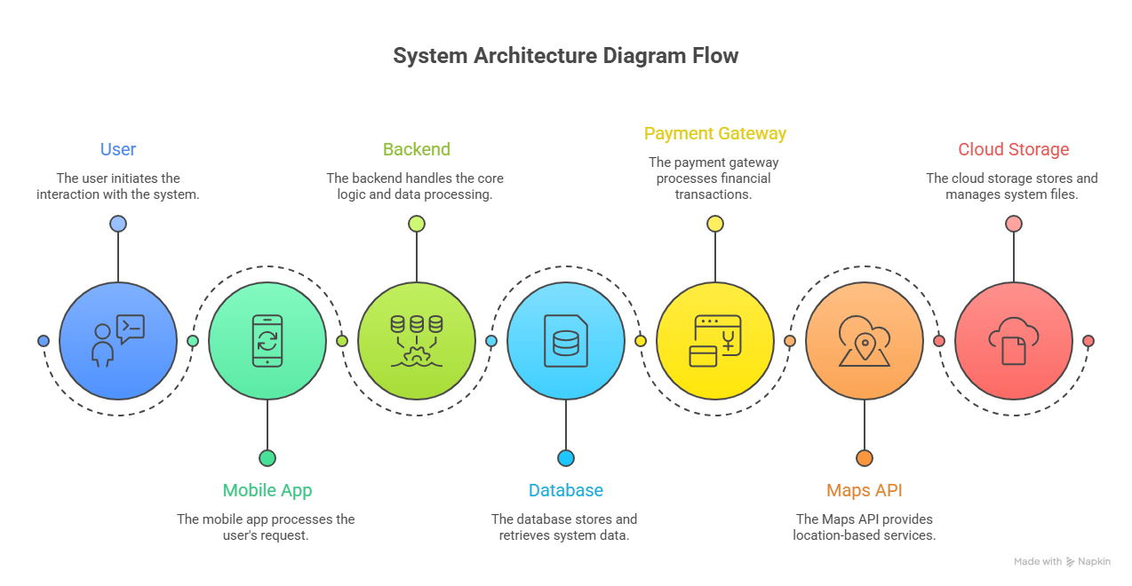
Fig 4.1 System Architecture Diagram Flow

4.1.1 Components of the Architecture
1. Frontend Mobile Application
The frontend of the system is developed using React Native with Expo, which enables cross-platform mobile development.
It acts as the user interface (UI) and is responsible for handling all interactions between the user and the system.
Key responsibilities:
- Displaying user data, pet details, and activity information
- Handling navigation between different screens and modules
- Capturing user input such as login credentials, pet data, and posts
- Sending API requests to the backend server
- Receiving responses and updating the UI dynamically
- Managing application states using state management techniques
The frontend uses reusable UI components and optimized rendering methods to provide a smooth, responsive, and user-friendly experience.
2. Backend API Server
The backend is developed using Node.js and Express.js, which handle all server-side operations.
It acts as the core processing unit of the system and manages communication between the frontend and the database.
Key responsibilities:
- Handling incoming API requests from the frontend
- Validating user input and request data
- Implementing business logic for different modules
- Managing authentication and authorization using secure methods
- Interacting with the database for CRUD operations
- Ensuring secure data transfer between client and server
The backend provides RESTful APIs, which allow the frontend to perform operations such as login, data retrieval, updates, and transactions efficiently.
3. Database
The system uses MongoDB, a NoSQL database, to store data in a flexible and scalable format.
Responsibilities:
- Storing user accounts and authentication details
- Managing pet profiles and related information
- Storing appointments and vaccination records
- Handling posts, comments, and chat messages
- Managing product, cart, and order data
MongoDB uses collections to organize data such as Users, Pets, Appointments, Vaccinations, Posts, Orders, etc., ensuring fast retrieval and efficient storage.
4. Third-Party Services
The application integrates external services to enhance functionality and reduce development complexity.
Examples:
- Payment Gateway: Enables secure transactions using UPI, cards, or wallets
- Maps & Location APIs: Helps in finding nearby clinics, stores, and parks
- Cloud Storage (e.g., Cloudinary): Stores images and videos efficiently
These services improve reliability, scalability, and performance of the application.
4.1.2 Architecture Flow
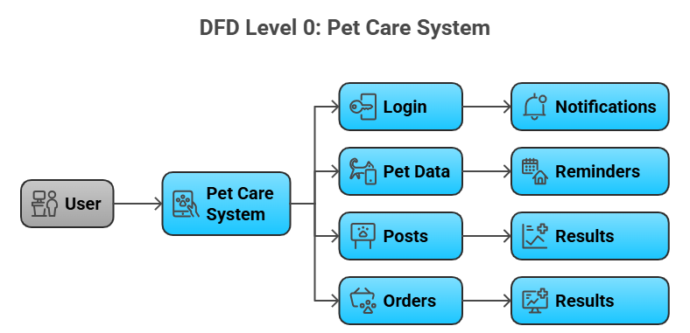
Fig 4.2 DFD Level: Pet Care System

The system follows a structured communication flow:
- User interacts with the mobile application
- The application sends a request to the backend API
- The backend processes the request and applies business logic
- The database is queried or updated accordingly
- The backend sends a response back to the frontend
- The frontend updates the UI based on the response
This structured flow ensures efficient data handling, fast response time, and smooth user experience.

4.2 Modules of the System
The system is divided into multiple modules to ensure modular development, easier maintenance, and better scalability.
4.2.1 Authentication Module
This module is responsible for providing secure access to the application.
Features:
- User registration with proper validation
- Login using email and password
- Password encryption using hashing techniques
- Token-based authentication (JWT)
- Session management and logout functionality
This module ensures that only authorized users can access the system and protects sensitive user data.
4.2.2 Dashboard & Navigation
The dashboard acts as the central hub of the application.
Features:
- Displays summary of pet activities and notifications
- Provides quick access to all modules
- Shows reminders and alerts
- Tab-based navigation for easy switching
Navigation is implemented using structured routing to ensure smooth transitions and better user experience.
4.2.3 Pet Profile Management
This module allows users to manage detailed information about their pets.
Features:
- Add new pet profiles
- Edit and update pet details
- Delete pet profiles
- Upload and manage pet images
Stored Data Includes:
- Pet name, breed, age, gender
- Weight and health information
- Medical notes
This helps users maintain a complete digital record of their pets.
4.2.4 Appointment Scheduler
This module manages all pet-related appointments.
Features:
- Create and schedule appointments
- Update or cancel appointments
- View upcoming and past appointments
- Set reminders for important events
It helps users stay organized and ensures that no important appointment is missed.
4.2.5 Vaccination Tracker
This module helps in tracking vaccination details.
Features:
- Add vaccine records
- Track vaccination dates
- Set reminders for next doses
- Maintain vaccination history
This ensures proper health monitoring and timely vaccination of pets.
4.2.6 Photo Gallery
This module handles all media-related functionalities.
Features:
- Upload images from device
- Capture photos using camera
- Organize photos based on pets
- View and manage gallery
Cloud storage is used to ensure efficient and secure media management.
4.2.7 Pet Social Network
This module enables social interaction among pet owners.
Features:
- Create posts with text, images, or videos
- Like and comment on posts
- Follow and unfollow users
- View feed/timeline
It creates a community-driven platform for sharing experiences and engaging with other pet lovers.
4.2.8 Encrypted Chat
This module provides private communication between users.
Features:
- One-to-one messaging
- Media sharing
- Real-time communication
- Optional end-to-end encryption
It ensures secure and direct communication within the platform.
4.2.9 Nearby Clinics & Reviews
This module uses location-based services.
Features:
- Search nearby veterinary clinics
- View ratings and user reviews
- Get directions using maps
Future Scope:
- Online appointment booking with clinics
4.2.10 Pet Food & Toy Store
This module supports e-commerce functionality.
Features:
- Browse pet products
- Sort and filter items
- Add products to cart
- View product reviews
4.2.11 Payment Integration
This module handles financial transactions.
Features:
- Secure payment processing
- Multiple payment methods
- Order confirmation
- Receipt generation
It ensures safe and smooth transaction experience.
4.2.12 Pet-Friendly Locations
This module helps users discover pet-friendly places.
Features:
- Search parks and restaurants
- View ratings and reviews
- Share user experiences

4.3 Use Case Description
The primary actor of the system is the User (Pet Owner).
User Actions:
- Register and log in
- Manage pet profiles
- Schedule appointments
- Track vaccinations
- Upload photos
- Create posts and interact socially
- Chat with other users
- Search for services and locations
- Purchase products
- Make payments
Use Case Flow Example (Login)
- User enters login credentials
- System validates input format
- Backend verifies user data from database
- If valid → access granted
- If invalid → error message displayed

4.4 Data Design
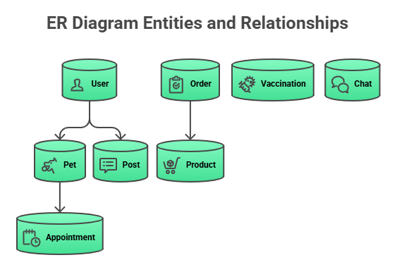
Fig 4.3 Entities and Relationships
The system uses a structured data model with multiple interconnected entities.
Main Entities:
- User
- Pet
- Appointment
- Vaccination
- Gallery
- Post
- Comment
- Follow
- Chat
- Clinic
- Store
- Product
- Cart
- Order
- Payment
- PetFriendlyLocation
Relationships:
- One user → multiple pets
- One pet → multiple appointments and vaccinations
- One user → multiple posts
- One order → multiple products
This structured design ensures efficient data storage, consistency, and easy retrieval.

4.5 User Interface Design
The user interface is designed to be simple, modern, and responsive.
Design Principles:
- Minimalistic layout
- Easy navigation
- Consistent design elements
- Fast loading screens
Main Screens:
- Login Screen
- Register Screen
- Home Dashboard
- Pet List Screen
- Add/Edit Pet Screen
- Appointment Screen
- Vaccination Screen
- Gallery Screen
- Social Feed Screen
- Chat Screen
- Nearby Services Screen
- Store & Cart Screen
- Payment Screen
- Profile Screen
Each screen is designed to provide clarity, usability, and a smooth user experience.

4.6 Testing Strategy
Testing is essential to ensure system reliability, performance, and security.
4.6.1 Unit Testing
- Tests individual components
- Ensures each function works correctly
4.6.2 Integration Testing
- Tests interaction between modules
- Ensures data flows correctly
4.6.3 API Testing
- Tests backend endpoints
- Performed using tools like Postman
4.6.4 UI Testing
- Checks user interface functionality
- Ensures proper navigation and usability
4.6.5 Performance Testing
- Measures speed and responsiveness
- Ensures system handles multiple users
4.6.6 Security Testing
Ensures protection against threats such as:
- Unauthorized access
- Data breaches
- Injection attacks
- Token misuse

CHAPTER 5. IMPLEMENTATION AND TESTING
5.1 Implementation Approach
The implementation of the proposed pet management system follows a modular and incremental development approach, where the system is divided into smaller functional units known as modules. Each module is developed, tested, and integrated step-by-step to ensure better performance, reliability, and maintainability.
This approach helps developers focus on individual functionalities without affecting the entire system. It also simplifies debugging and testing processes.
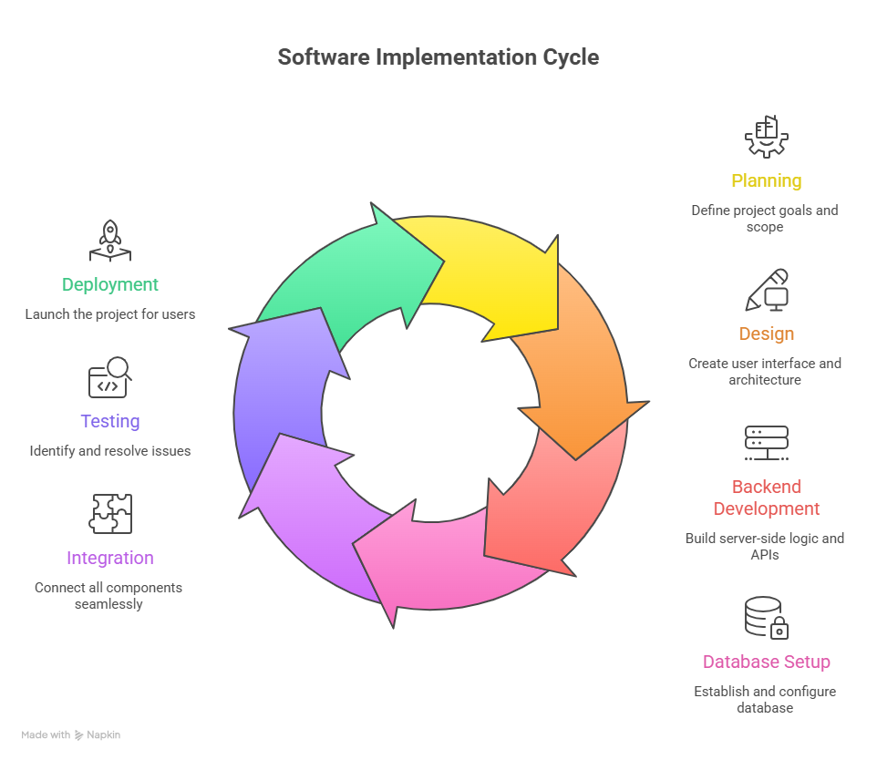
Fig 5.1 Software Implementation Cycle

Advantages of Modular Approach
- Easier development and maintenance
- Better code organization and readability
- Independent testing of each module
- Faster identification and resolution of errors
- Flexibility to add new features in future
The system is based on a client-server architecture, where:
- The frontend mobile application handles user interaction
- The backend server processes requests and applies business logic
- The database (MongoDB) stores and retrieves data
The frontend communicates with the backend using RESTful APIs, ensuring smooth and structured data exchange.
Implementation Workflow
The development process is carried out in the following steps:
- Requirement analysis and system planning
- UI/UX design of the mobile application
- Backend API development
- Database schema design
- Integration of frontend and backend
- Testing of individual modules
- Final deployment and testing
Technology Stack Used
- Frontend: React Native (Expo)
- Backend: Node.js, Express.js
- Database: MongoDB
- API Testing: Postman
- Version Control: Git (optional)
These technologies ensure that the system is scalable, efficient, and easy to maintain.

5.2 Module Implementation
Each module is implemented independently to ensure proper functionality and easier debugging.
5.2.1 Authentication Module
This module manages user identity verification and secure access.
Implementation Details
- Registration API stores user data in database
- Passwords are encrypted using hashing (bcrypt)
- Login API validates credentials
- JWT tokens are generated for session handling
- Token verification is used for protected routes
Features Implemented
- User registration
- Secure login and logout
- Token-based authentication
- Input validation
Outcome
Ensures secure access to the system and protects sensitive user data.
5.2.2 Pet Management Module
This module handles all pet-related data.
Implementation Details
- CRUD operations implemented using REST APIs
- Pet data stored in MongoDB collections
- Image upload handled via cloud storage or local storage
Features Implemented
- Add new pet profiles
- Edit pet details
- Delete pet profiles
- View pet information
Outcome
Provides structured and organized storage of pet data for easy access.
5.2.3 Appointment Module
This module manages scheduling and reminders.
Implementation Details
- Appointment data stored in database
- APIs handle creation, updating, and deletion
- Reminder system implemented using notifications
Features Implemented
- Create appointments
- Update and delete appointments
- View appointment history
- Set reminders
Outcome
Helps users manage pet-related schedules efficiently and avoid missing important events.
5.2.4 Vaccination Module
This module tracks vaccination records.
Implementation Details
- Vaccination data stored in MongoDB
- Due dates calculated and saved
- Reminder notifications implemented
Features Implemented
- Add vaccination records
- Update records
- Track due dates
- View vaccination history
Outcome
Ensures timely vaccination and better health management of pets.
5.2.5 Gallery Module
This module manages images and media.
Implementation Details
- Image picker used to select images
- Media uploaded to cloud storage
- Metadata stored in database
Features Implemented
- Upload images
- Capture photos
- View gallery
- Delete images
Outcome
Allows users to maintain a digital collection of pet memories.
5.2.6 Social Module
This module enables social interaction.
Implementation Details
- Posts stored in database
- Likes and comments handled using relational mapping
- Feed generated dynamically
Features Implemented
- Create posts
- Like and comment
- Follow/unfollow users
- View feed
Outcome
Builds a community platform for pet lovers.
5.2.7 Chat Module
This module supports messaging between users.
Implementation Details
- Messages stored in database
- APIs handle message sending and retrieval
- Optional WebSocket for real-time chat
Features Implemented
- One-to-one messaging
- Media sharing
- Chat history
Outcome
Provides secure and efficient communication between users.
5.2.8 Location Module
This module provides location-based services.
Implementation Details
- GPS used to fetch current location
- Maps API integrated
- Nearby services fetched dynamically
Features Implemented
- Search nearby clinics
- View directions
- Display maps
Outcome
Improves accessibility to pet-related services.
5.2.9 Shopping Module
This module handles e-commerce functionality.
Implementation Details
- Products stored in database
- Cart functionality implemented
- Orders processed via APIs
Features Implemented
- Browse products
- Add to cart
- Place orders
- View order history
Outcome
Provides a seamless shopping experience for users.
5.2.10 Payment Module
This module handles transactions.
Implementation Details
- Payment gateway APIs integrated
- Secure transaction processing implemented
- Order confirmation generated
Features Implemented
- Online payments
- Multiple payment options
- Transaction confirmation
Outcome
Ensures secure and reliable financial transactions.

5.3 API Integration
The mobile application communicates with the backend using RESTful APIs.
API Categories
Authentication APIs
- Register user
- Login user
Pet APIs
- Add pet
- Update pet
- Delete pet
- Fetch pet data
Appointment APIs
- Create appointment
- Update appointment
- Delete appointment
Vaccination APIs
- Add vaccination record
- Fetch records
Social APIs
- Create post
- Like/comment
Chat APIs
- Send message
- Retrieve chat
Shopping APIs
- Fetch products
- Manage cart
- Place order
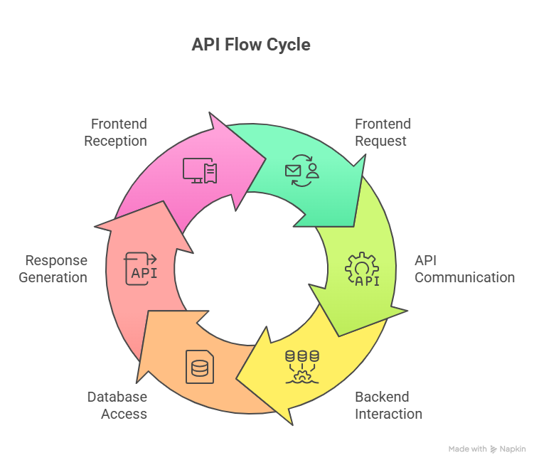
Fig 5.2 API Flow Cycle

API Communication Flow
- Frontend sends request
- Backend processes request
- Database operation performed
- Response returned to frontend
This ensures smooth communication between system components.

5.4 Testing Methods
Testing is essential to ensure that the system functions correctly and meets all requirements.
5.4.1 Unit Testing
- Tests individual components or functions
- Ensures each module works independently
Examples:
- Login function
- Pet creation function
5.4.2 Integration Testing
- Tests interaction between modules
- Ensures proper data flow
Examples:
- Frontend-backend communication
- API response handling
5.4.3 System Testing
- Tests the entire system as a whole
- Ensures all modules work together
5.4.4 Beta Testing
- Application tested in real-world environment
- Performed by users
Objectives:
- Identify usability issues
- Detect bugs
- Gather feedback
5.4.5 Performance Testing
- Measures system speed and responsiveness
- Ensures system can handle multiple users
5.4.6 Security Testing
Ensures system protection against threats.
Checks include:
- Authentication security
- Data encryption
- API protection
- Unauthorized access prevention

CHAPTER 6. RESULTS AND DISCUSSION
6.1 System Output
The developed pet management application successfully integrates multiple functionalities into a single mobile platform, providing a unified solution for pet owners. The system was implemented using modern technologies and tested under various real-world scenarios to evaluate its performance, reliability, and usability.
The final output demonstrates that users can efficiently manage all pet-related activities such as maintaining records, scheduling appointments, tracking vaccinations, interacting socially, and purchasing products through a single application. The system eliminates the need for multiple platforms, thereby improving efficiency and reducing complexity.
The application provides a smooth and responsive user experience, supported by optimized UI design, efficient backend processing, and real-time data handling.
6.1.1 User Registration and Login
The system provides a secure and efficient authentication mechanism.
Observed Results:
- Users are able to register successfully using valid details
- Passwords are securely stored using encryption techniques
- Login process is smooth and fast
- Proper error messages are displayed for invalid credentials
- Session management works correctly
This ensures that only authorized users can access the system, maintaining data privacy and security.
6.1.2 Pet Profile Management
The system allows users to create and manage multiple pet profiles effectively.
Observed Results:
- Users can add and manage multiple pets
- Pet details such as breed, age, and health information are stored accurately
- Editing and deletion operations function without errors
- Pet profile images are uploaded and displayed correctly
This feature provides a structured and organized way to store pet information, improving accessibility and data management.
6.1.3 Appointment Scheduling
The appointment module helps users manage pet-related schedules.
Observed Results:
- Appointments can be created, updated, and deleted successfully
- Reminder notifications are triggered correctly
- Appointment history is stored and displayed accurately
This functionality ensures that users do not miss important veterinary visits or grooming sessions.
6.1.4 Vaccination Tracking
The vaccination module ensures proper health tracking for pets.
Observed Results:
- Vaccination records can be added and updated easily
- Due dates are calculated and displayed correctly
- Reminder system functions as expected
- Vaccination history is maintained and accessible
This improves pet health management by ensuring timely vaccinations and reducing health risks.
6.1.5 Gallery Management
The gallery module allows users to manage pet images.
Observed Results:
- Images can be uploaded from the device or captured using the camera
- Images are displayed in an organized grid format
- Deletion functionality works properly
This feature enhances user experience by allowing users to maintain a digital collection of pet memories.
6.1.6 Social Interaction
The social module creates a platform for user engagement.
Observed Results:
- Users can create posts with images and videos
- Like and comment features function correctly
- Follow/unfollow functionality works efficiently
- Feed updates dynamically based on user activity
This module successfully creates a community environment for pet owners to share experiences and interact.
6.1.7 Chat System
The chat module supports communication between users.
Observed Results:
- Messages are delivered successfully
- Chat history is stored and retrieved correctly
- Media sharing is supported
This improves interaction and enables direct communication between users.
6.1.8 Location-Based Services
The system integrates GPS and mapping services.
Observed Results:
- User location is detected accurately
- Nearby clinics, stores, and parks are displayed correctly
- Navigation and directions function properly
This feature enhances convenience by helping users access nearby services quickly.
6.1.9 Shopping Module
The shopping module provides e-commerce functionality.
Observed Results:
- Product listings are displayed correctly
- Users can add items to the cart
- Orders can be placed successfully
- Order history is maintained
This module simplifies the process of purchasing pet-related products.
6.1.10 Payment System
The payment module ensures secure transactions.
Observed Results:
- Payments are processed successfully
- Multiple payment methods are supported
- Order confirmation is generated after payment
This ensures a safe and reliable payment experience.
6.1.11 Overall System Performance
The system performs efficiently under normal usage conditions.
Performance Observations:
- Fast response time for API requests
- Smooth navigation across screens
- Minimal loading delays
- Stable performance without crashes
This indicates that the system is reliable and optimized for real-world usage.

6.2 Advantages of the System
The developed system offers several advantages compared to traditional methods and existing fragmented solutions.
Centralized Pet Care Management
All pet-related functionalities are integrated into a single platform, reducing dependency on multiple applications and simplifying user experience.
Improved Organization
The system provides structured storage of data such as pet profiles, appointments, and vaccination records, making it easy to access and manage information.
Time Efficiency
Users can perform multiple tasks within one application, saving time and effort. Automated reminders further enhance productivity.
Enhanced User Experience
The application offers a clean and intuitive interface with smooth navigation and responsive design, making it easy to use.
Social Connectivity
The social module allows users to connect with other pet owners, share content, and build a community.
Convenience in Shopping and Payments
Integrated shopping and payment features provide a seamless purchasing experience without switching platforms.
Accessibility to Nearby Services
Location-based features help users easily find nearby clinics, stores, and pet-friendly places.
Data Security
Secure authentication and encryption techniques ensure that user data is protected
Scalability
The system is designed to handle increasing users and can be extended with additional features
Reliability
The system performs consistently and maintains data accuracy, ensuring dependable operation.

6.3 Limitations
Despite its advantages, the system has certain limitations
Limited Real-Time Booking
The system currently does not support direct booking with clinics. Users may need to contact clinics separately.
Chat Security Limitations
Full end-to-end encryption may not be implemented in the current version.
Payment Gateway Restrictions
Payment features may be limited in testing environments and require additional setup for production use.
Internet Dependency
The application requires an active internet connection for most functionalities.
Performance Constraints
Heavy usage or large datasets may impact performance if not optimized further.
Limited Advanced Features
Advanced features such as AI recommendations, predictive health tracking, and smart alerts are not included.
Platform Dependency
The application may currently be optimized mainly for Android devices.

6.4 Discussion
The results clearly indicate that the proposed system effectively addresses the limitations of the existing system by providing a centralized and integrated solution.
The application improves efficiency, organization, and accessibility, allowing users to manage all pet-related activities in one place. The modular architecture ensures that each component works independently while maintaining seamless integration, making the system reliable and scalable.
The addition of features such as social interaction, e-commerce, and location-based services enhances the overall functionality of the application, transforming it into a complete ecosystem for pet owners.
However, certain limitations such as internet dependency and lack of advanced features highlight areas for future improvement. By addressing these limitations, the system can be further enhanced to provide even better performance and user experience.

CHAPTER 7. CONCLUSION AND FUTURE SCOPE
7.1 Conclusion
The development of the Pet Care and Social Networking Mobile Application represents a significant advancement in simplifying and improving the way pet owners manage their pets’ daily needs. The primary objective of this project was to design and implement a centralized, user-friendly, and efficient platform that integrates multiple pet-related services into a single mobile application.
Based on the system implementation, testing results, and observed performance, it can be concluded that the application successfully achieves its intended goals. The system effectively eliminates the need for using multiple applications by combining essential features such as pet profile management, vaccination tracking, appointment scheduling, social interaction, chat functionality, e-commerce, and location-based services.
In traditional systems, pet owners face challenges such as scattered data, missed reminders, lack of organization, and difficulty in accessing relevant services. The proposed system addresses these problems by providing a structured and integrated solution, which enhances efficiency, reduces effort, and improves user experience.
One of the key strengths of the application is its modular architecture, where each component operates independently while maintaining seamless integration with other modules. This design ensures better performance, easier debugging, and flexibility for future enhancements.
The application also improves user convenience and productivity by enabling users to perform multiple tasks within a single platform. Features such as automated reminders for appointments and vaccinations help users manage time effectively and ensure that important activities are not overlooked.
The inclusion of a social networking module adds an interactive dimension to the system, allowing users to share posts, interact with other pet owners, and build a community. This enhances engagement and promotes knowledge sharing related to pet care.
The integration of shopping and payment modules further enhances the functionality of the application by enabling users to purchase pet-related products directly within the app. This provides a seamless and convenient shopping experience. Additionally, the use of location-based services allows users to easily find nearby clinics, stores, and pet-friendly places, improving accessibility.
From a technical perspective, the system demonstrates efficient use of modern technologies such as React Native, Node.js, Express.js, and MongoDB. The use of RESTful APIs ensures smooth communication between the frontend and backend, while security measures such as authentication and password encryption protect user data.
Testing results confirm that the system is stable, reliable, and performs efficiently under normal conditions. All major modules function as expected, and the application delivers a smooth and responsive user experience.
However, certain limitations such as dependency on internet connectivity, limited real-time integrations, and absence of advanced intelligent features highlight areas for improvement.
In conclusion, the project successfully demonstrates how modern technology can be used to develop a comprehensive, efficient, and scalable pet care system. The application not only simplifies pet management but also enhances the overall user experience, providing a strong foundation for future developments and innovations.

7.2 Future Scope
Although the current system provides a wide range of functionalities, there is significant scope for further enhancement and expansion. Future improvements can focus on adding advanced features, improving system performance, and increasing user engagement.
7.2.1 Online Veterinary Appointment Booking
In the current system, appointment scheduling is handled manually. This can be enhanced by integrating real-time booking systems with veterinary clinics.
Future improvements may include:
- Viewing available time slots
- Booking appointments directly through the app
- Receiving instant confirmations
- Canceling or rescheduling appointments
This will improve convenience and reduce dependency on external communication.
7.2.2 AI-Based Health Recommendations
Artificial Intelligence can be integrated to provide personalized pet care solutions.
Possible enhancements include:
- Health analysis based on pet data
- Diet and nutrition recommendations
- Early detection of health issues
- Preventive care suggestions
This will make the system more intelligent and supportive for pet health management.
7.2.3 Smart Reminders with Notifications
The current reminder system can be enhanced with intelligent features.
Future features may include:
- Predictive reminders based on user behavior
- Priority-based alerts
- Customizable notification settings
- Integration with wearable devices
This will improve task management and user engagement.
7.2.4 Multi-User Family Access
Currently, the system is designed for single-user access. Future versions can allow multiple users to manage the same pet.
Benefits include:
- Shared responsibilities among family members
- Real-time updates across users
- Better coordination in pet care
7.2.5 Pet Adoption and Rescue Section
A new module can be added for pet adoption and rescue services.
Features may include:
- Listing pets available for adoption
- Connecting with shelters and NGOs
- Online adoption application system
- Reporting rescue cases
This would promote social responsibility and animal welfare.
7.2.6 Video Calling with Veterinarians
Telemedicine features can be introduced to allow remote consultation.
Future features:
- Video calls with veterinarians
- Instant health advice
- Emergency consultation
This will provide quick and convenient access to professional support.
7.2.7 Live Order Tracking
The shopping module can be improved by adding real-time tracking features.
Enhancements include:
- Tracking delivery status
- Estimated delivery time
- Notifications for order updates
This improves transparency and user satisfaction.
7.2.8 Advanced Chat Encryption
The chat module can be enhanced with stronger security measures.
Future improvements:
- End-to-end encryption
- Secure media sharing
- Advanced privacy controls
This will ensure better protection of user communication.
7.2.9 Web Version of the Platform
Currently, the system is mobile-based. A web version can be developed.
Benefits:
- Access from desktops and laptops
- Improved usability for administrators
- Increased user reach
7.2.10 Wearable Pet Device Integration
Integration with smart pet devices can enhance monitoring capabilities.
Possible features:
- Tracking pet activity and health
- GPS-based location tracking
- Real-time alerts
This would transform the system into a smart pet care ecosystem.

APPENDIX

The Dashboard Page serves as the central hub of the app, providing users with easy access to all important features in one place. It includes options like managing pets, tracking vaccinations, scheduling appointments, finding nearby clinics and pet stores, viewing pet photos in the gallery, and updating user profile details. The dashboard is designed to be simple and user-friendly, ensuring smooth navigation and efficient pet care management.
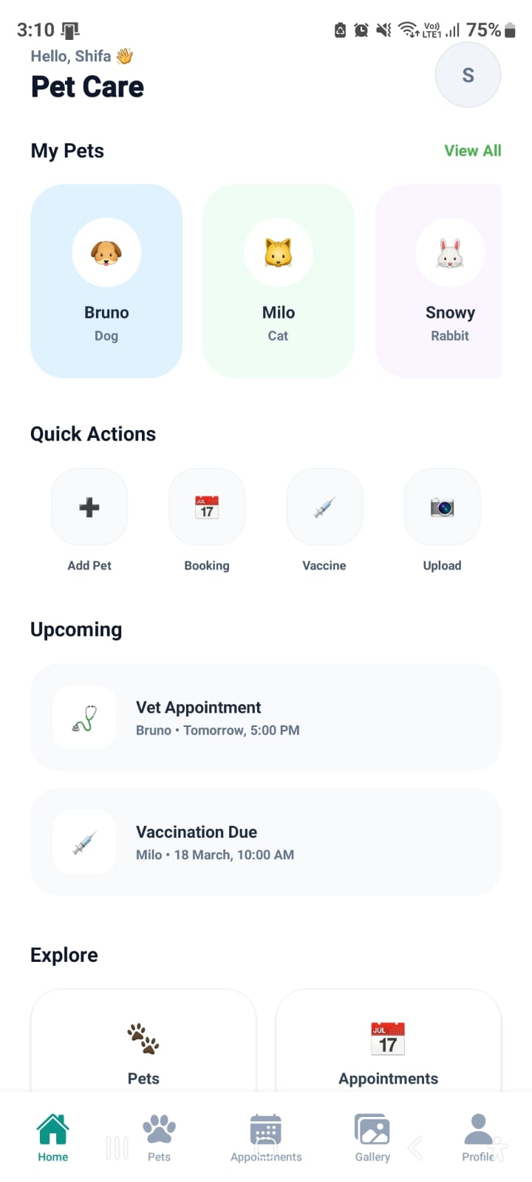
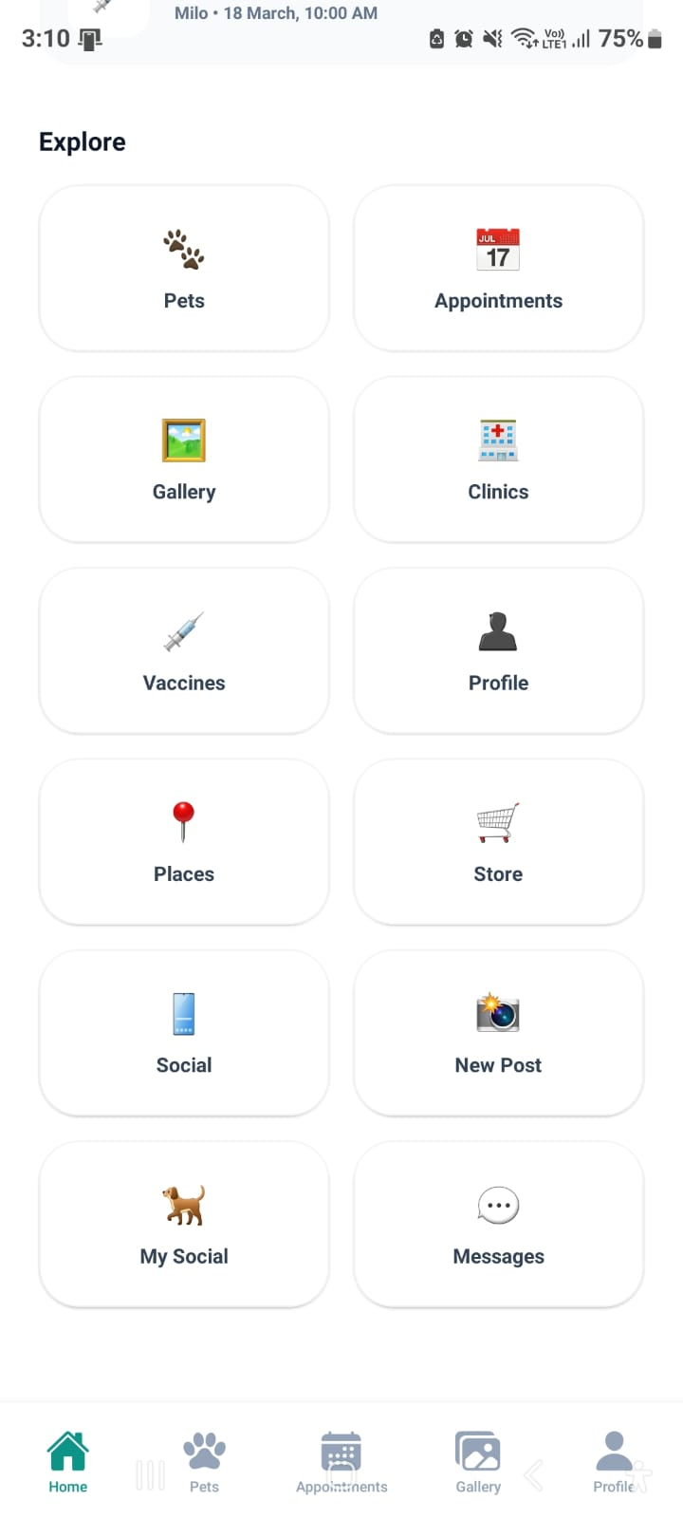

Pets Page:
The Pets Page allows users to add, view, and manage details of their pets. It includes information such as pet name, age, breed, and health details. Users can update or delete pet profiles easily, making it simple to keep all pet-related information organized in one place.

Appointments Page:
The Appointments Page enables users to schedule, view, and manage veterinary appointments. It provides details of upcoming and past visits, along with reminders to ensure timely check-ups and treatments for pets.

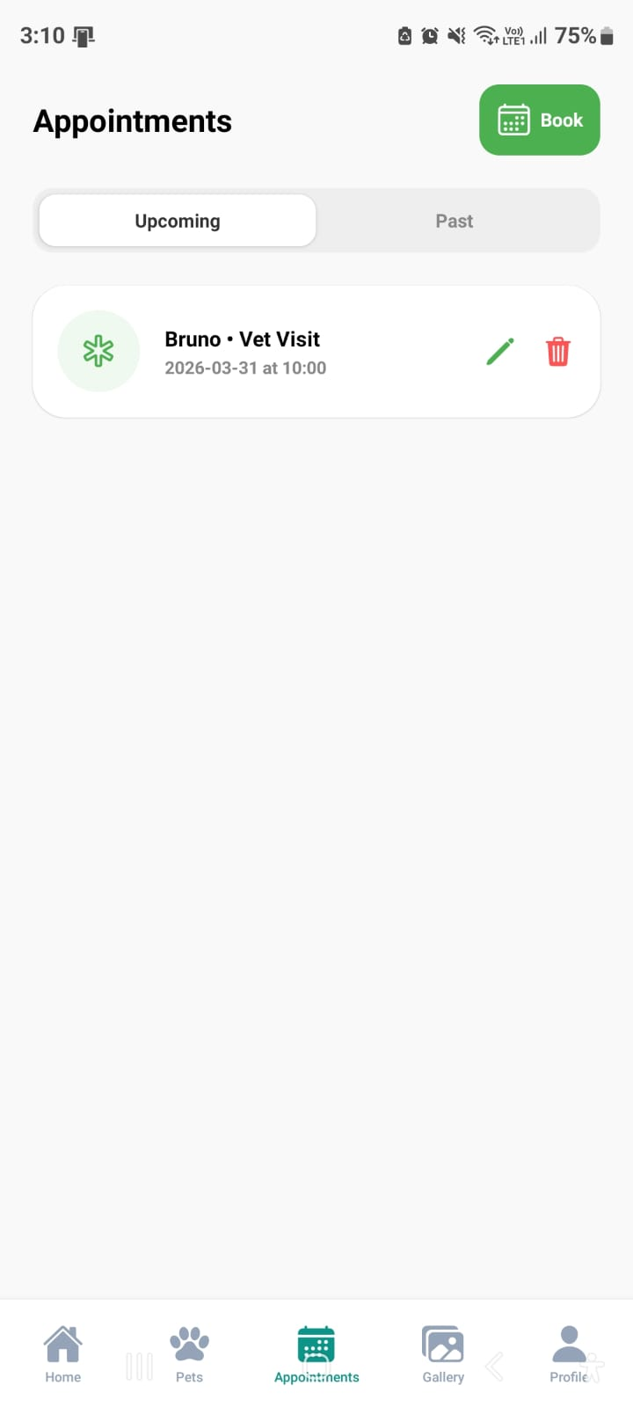
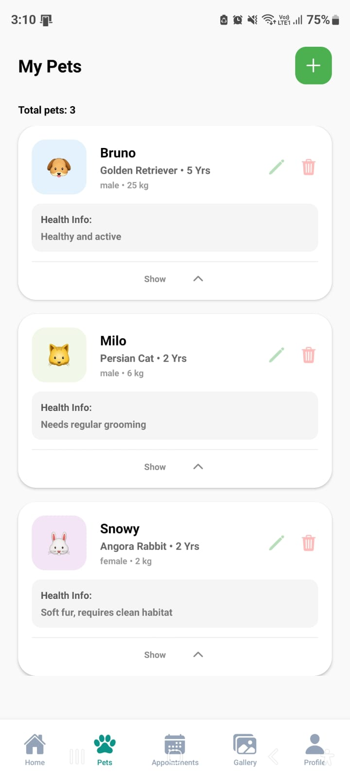

Vaccination Page:
The Vaccination Page helps users track their pet’s vaccination records. It displays upcoming and completed vaccines, along with dates and reminders, ensuring pets stay protected and healthy.

Clinic Page:
The Clinic Page allows users to find nearby veterinary clinics. It provides details such as clinic names, locations, and contact information, making it easy to access medical services for pets when needed.
